AI ASSISTED CODING
LAB ASSIGNMENT – 10.4
Student Name | HARSHITH PATHIPAKA
Batch | 05
Enrollment Number | 2503A52141
Course Code | 23CS002PC304
Course Title | AI Assisted Coding
Assignment Topic | Lab 9 – Code Review and Quality: Using AI to Improve Code Quality and Readability

Task 1 – AI-Assisted Syntax and Code Quality Review
The task focuses on identifying syntax and structural errors, correcting them systematically, explaining the fixes, and producing a clean executable Python program.
The assignment specifically lists syntax errors, indentation issues, incorrect variable names, and faulty function calls. fileciteturn0file0L49-L69

2.1 Prompt Used
Review the following Python code as a senior Python code reviewer.
1. Identify every syntax, indentation, naming, and function-call error.
2. Correct the code without changing its intended functionality.
3. Explain every correction.
4. Apply PEP 8 naming and formatting conventions.
5. Return the final executable code.

CODE:
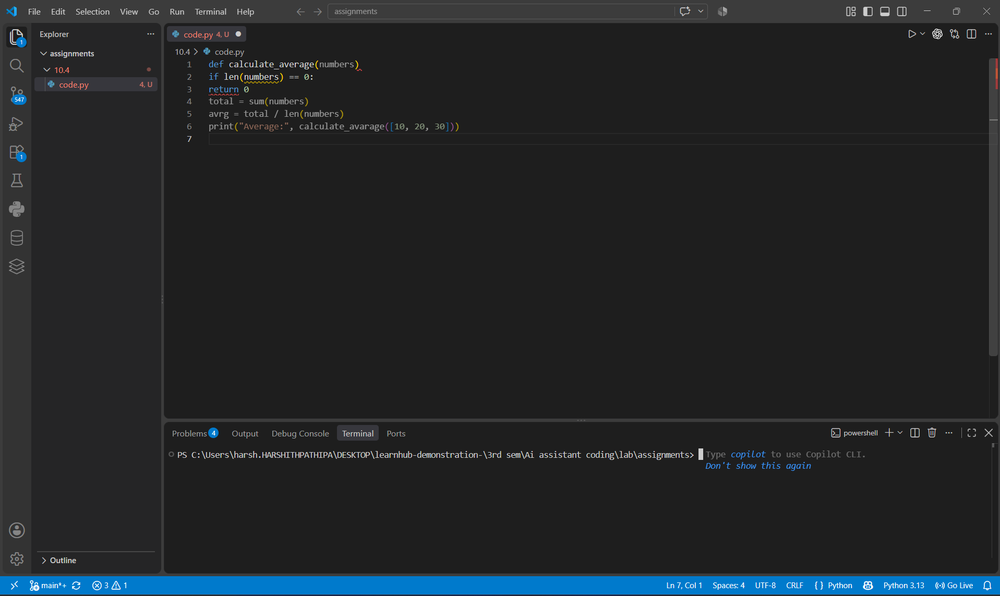

2.2 Original Code Issues
- Missing colon after the function definition.
- Incorrect indentation inside the function.
- The function body is not structurally nested.
- The local variable name 'avrg' is unclear.
- The function call uses 'calculate_avarage', which does not match the declared function name.
- The function is defined to accept numbers, but the final call should use the corrected function name.

2.3 Corrected Code

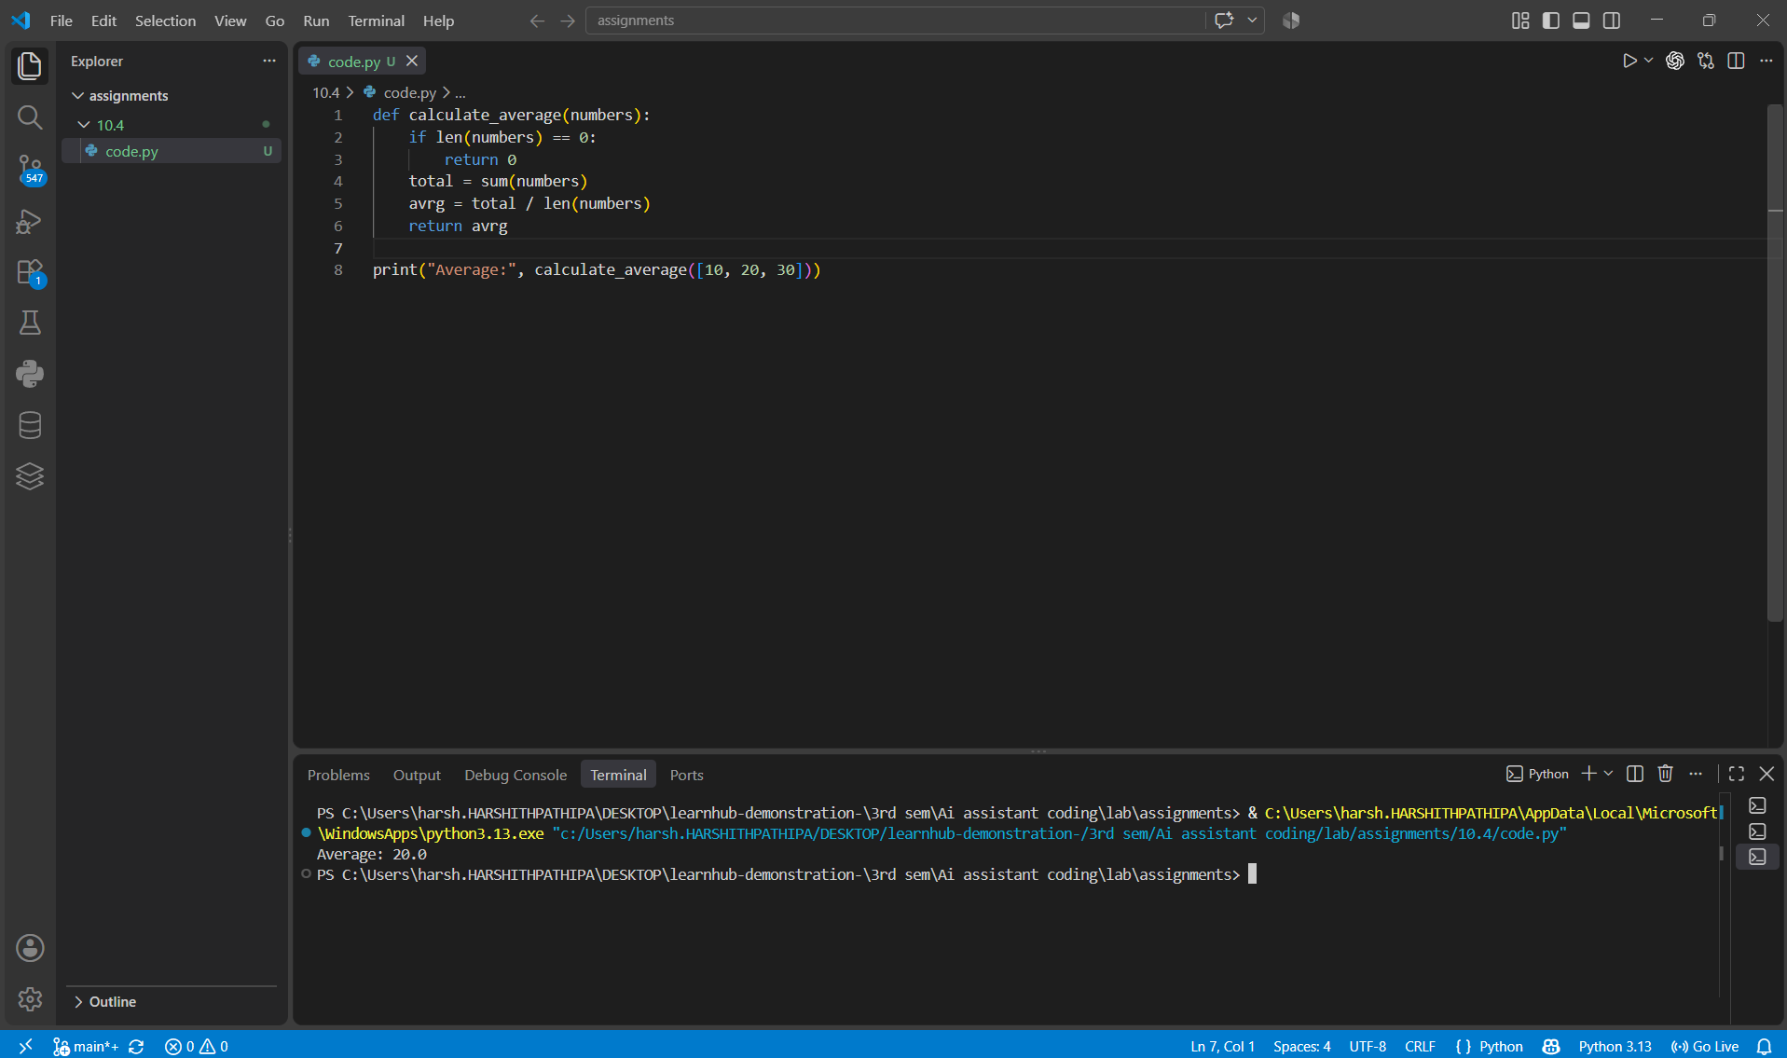2.4 AI-Generated Explanation / Review
- Syntax: Added the missing colon after the function definition.
- Structure: Corrected indentation so statements belong to the appropriate function blocks.
- Naming: Replaced the abbreviated variable 'avrg' with the descriptive name 'average'.
- Function call: Corrected the misspelled function name.
- Quality: Added a return statement so the function has a clear output.
- Readability: Added blank lines between logical sections in accordance with common PEP 8 style.

2.5 Output
Average: 20.0

3. Task 2 – Performance-Oriented Code Review
This task asks for analysis of an inefficient duplicate-detection function, refactoring for better time complexity, preservation of correctness, and an explanation of the performance improvement.
The assignment explicitly recommends set/hash-based structures as an optimized approach. fileciteturn0file0L76-L85

3.1 Prompt Used
Review this duplicate-detection function for performance.
1. Explain the bottleneck and time complexity.
2. Refactor it using an appropriate hash-based data structure.
3. Preserve the order of the first occurrence of each duplicate.
4. Explain the complexity before and after optimization.
5. Provide clean, readable Python code.
Code:
def find_duplicates(values):
duplicates = []
for i in range(len(values)):
for j in range(i + 1, len(values)):
if values[i] == values[j] and values[i] not in duplicates:
duplicates.append(values[i])
return duplicates

3.2 Original Code

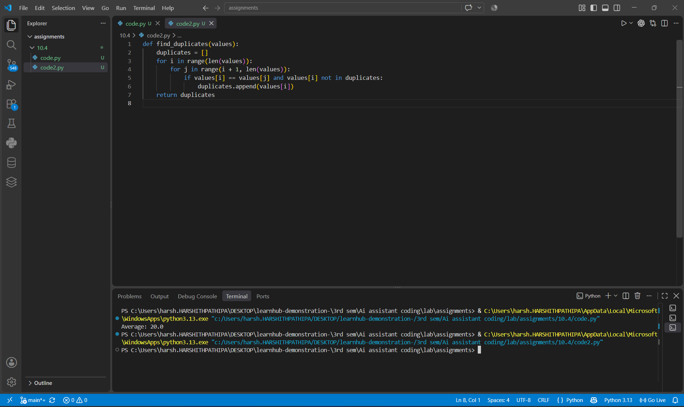3.3 Performance Analysis
- The nested loops compare many pairs of elements, producing O(n²) comparisons in the worst case.
- The membership test 'value not in duplicates' is also linear in the size of the duplicates list.
- For large datasets, the repeated comparisons become expensive.

3.4 Optimized Code

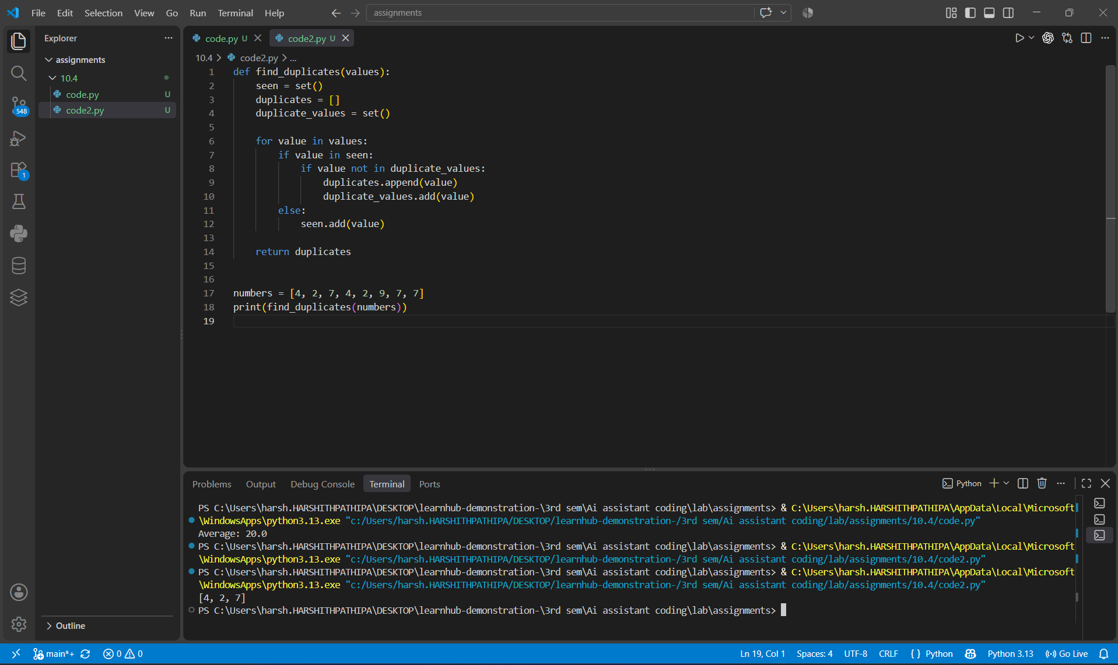3.5 Complexity Comparison
Approach | Typical Time Complexity | Main Reason
Nested loops | O(n²) | Repeated pairwise comparisons
Set-based approach | O(n) average | Average O(1) membership checks

3.6 Output
[4, 2, 7]
The optimized implementation preserves the first-occurrence order of duplicated values while reducing the average-time behavior from quadratic to linear.

4. Task 3 – Readability and Maintainability Refactoring
This task requires refactoring a poorly structured Python function by improving naming, indentation, formatting, documentation, and overall clarity.
The assignment calls for PEP 8 formatting, meaningful naming, documentation, and docstrings. fileciteturn0file0L86-L105

4.1 Prompt Used
Refactor the following Python function for long-term maintainability.
1. Use descriptive function and variable names.
2. Apply PEP 8 formatting.
3. Improve indentation and structure.
4. Add a useful docstring.
5. Add comments only where they improve understanding.
6. Preserve the original behavior.
7. Explain the readability improvements.
Code:
def calc(x,y):
z=x*y
if z>100:
return z*.9
else:
return z

4.2 Refactored Code

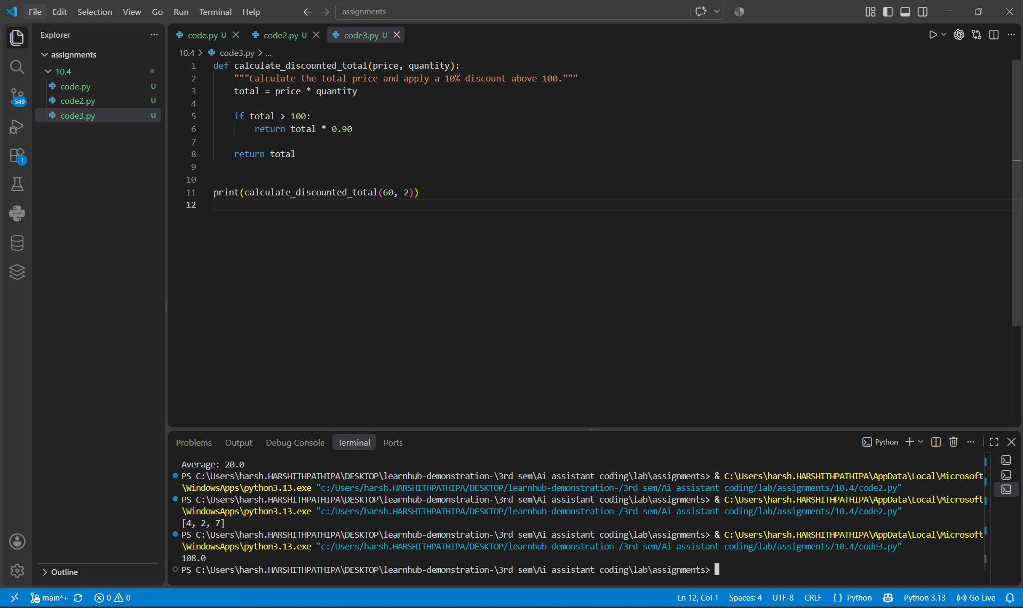4.3 Readability Improvements
- Changed 'calc' to 'calculate_discounted_total' so the function purpose is immediately clear.
- Replaced 'x' and 'y' with 'price' and 'quantity'.
- Replaced 'z' with 'total'.
- Applied consistent four-space indentation.
- Added a docstring describing the function's purpose and discount rule.
- Used clear spacing around operators and separated logical sections.
- Preserved the original behavior.

4.4 Output
108.0

5. Task 4 – Secure Coding and Reliability Review
This task concerns a backend function that retrieves user data. The review must identify unsafe SQL construction, missing input validation, and missing exception handling, then improve security and reliability.
The assignment requires parameterized SQL statements, input validation, try-except handling, and a production-ready structure. fileciteturn0file0L108-L126

5.1 Prompt Used
Review the following Python database function for security and reliability.
1. Identify SQL injection risk and other security issues.
2. Replace unsafe SQL construction with a parameterized query.
3. Validate the user ID.
4. Add appropriate exception handling.
5. Avoid exposing sensitive database errors to the user.
6. Explain each security improvement.
Code:
def get_user(connection, user_id):
query = "SELECT id, name, email FROM users WHERE id = " + user_id
cursor = connection.cursor()
cursor.execute(query)
return cursor.fetchone()

5.2 Security Issues Identified
- Unsafe string concatenation can allow SQL injection when untrusted input reaches the query.
- The input is not validated before database access.
- There is no exception handling for database failures.
- The original function does not explicitly close the cursor.
- Production code should avoid returning raw database exception details to end users.

5.3 Secure Refactored Code

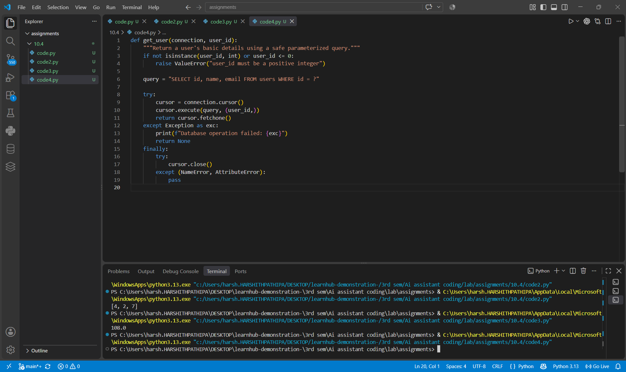5.4 Security Improvements
- Parameterized SQL separates SQL instructions from user-supplied values.
- Input validation ensures the user ID is a positive integer.
- Exception handling prevents an unexpected database failure from crashing the caller.
- The function returns a controlled result instead of exposing a raw database traceback to the application user.
- The cursor is closed in a finally block when it was successfully created.
Note: The placeholder style '?' is appropriate for SQLite. Other database drivers may use a different parameter style, so the exact placeholder should match the selected database library.

6. Task 5 – AI-Based Automated Code Review Report
The final task demonstrates AI as a reviewer rather than only a code generator. The report evaluates readability, naming, formatting, error handling, documentation, maintainability, risk areas, code smells, and improvement suggestions.
The assignment specifically asks for identified quality issues, risk areas, code-smell detection, and improvement suggestions. fileciteturn0file0L127-L152

6.1 Prompt Used
Act as an AI code reviewer. Do not rewrite the code immediately.
First analyze the following Python script and produce a structured review covering:
- Readability
- Naming conventions
- Formatting/style consistency
- Error handling
- Documentation
- Maintainability
- Code smells
- Security/reliability risks
Then provide prioritized improvement suggestions.
Finally, provide an improved version of the code.
Code:
def process(data):
r=[]
for i in range(len(data)):
try:
if data[i]["age"] >= 18:
r.append(data[i]["name"].upper())
except:
pass
return r

6.2 AI Code Review Report
Area | Issue | Risk / Impact | Recommendation
Readability | Single-letter variable 'r' and generic function name 'process'. | Harder to understand and maintain. | Use descriptive names.
Naming | Parameter 'data' is too generic. | Unclear expected structure. | Use a name such as 'users'.
Formatting | Missing spaces and non-PEP 8 formatting. | Inconsistent style. | Apply PEP 8 formatting.
Error handling | Bare 'except:' silently ignores all errors. | Hides programming and data errors. | Catch expected exceptions explicitly.
Documentation | No docstring or type hints. | Function contract is unclear. | Add docstring and optional type hints.
Maintainability | Logic relies on dictionary keys without validation. | Malformed records can fail unexpectedly. | Validate required fields or use a clear data model.
Code smell | Index-based iteration over a list. | Unnecessary complexity. | Iterate directly over records.

6.3 Improved Version

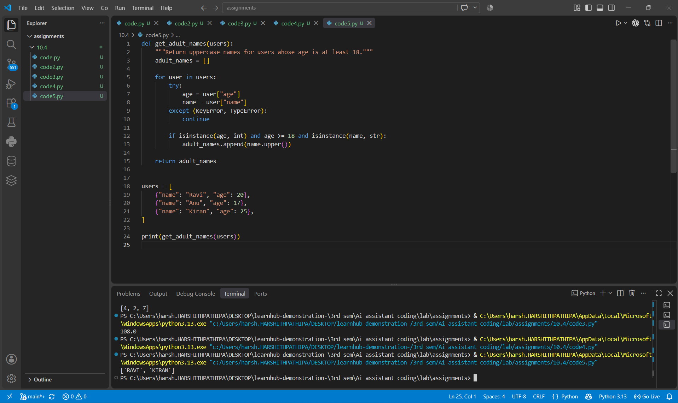6.4 Output
['RAVI', 'KIRAN']

6.5 Overall AI Review Summary
- Readability improved through descriptive names and direct iteration.
- PEP 8 style was applied through spacing, indentation, and clear structure.
- Error handling became targeted instead of using a bare except clause.
- Documentation was added through a docstring.
- The function's intent is now clear from its name and structure.
- The improved code is easier to review, test, and maintain.

7. Conclusion
This assignment demonstrates how AI can be used as a code-review assistant across different quality dimensions. The examples show that AI-assisted review is not limited to generating code: it can identify syntax and structural errors, suggest performance improvements, improve readability, identify security risks, and produce a structured review report. Human review remains important to verify correctness, security, compatibility with the selected libraries, and whether an AI suggestion actually preserves the intended behavior.

